**Computer Lab 101 Assignment**

**1. Program to print the table of a number.**

#!/bin/sh

echo "Enter the number:"

read num

i=1

while [ $i -le 10 ]

do

echo " $num * $i = $(( num * i )) "

i=$(( i+1 ))

done

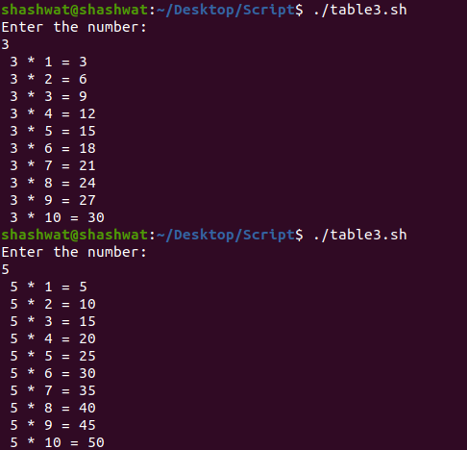

**2. Program to check if the entered number is a multiple of both 3 and 5.**

#!/bin/sh

echo "Enter a number "

read a

m=$a

n=$(($a % 3))

m=$(($m % 5))

if [ $n -eq 0 ] && [ $m -eq 0 ]

then

echo "Mutiple of 3 and 5 "

elif [ $n -eq 0 ]

then

echo "Multiple of 3 only"

elif [ $m -eq 0 ]

then

echo "Multiple of 5 only"

else

echo "Neiher multiple of 3 nor 5"

fi

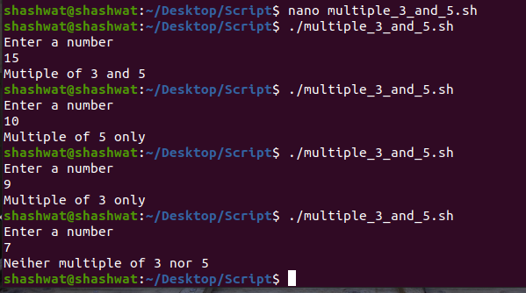

**3. Program to find power of a number (eg. 5^3 = 125).**

echo "Enter the number : "

read num

echo "Enter power:"

read pow

a=1

c=1

while [ $a -le $pow ]

do

c=$((c * num))

a=$((a + 1))

done

echo $c

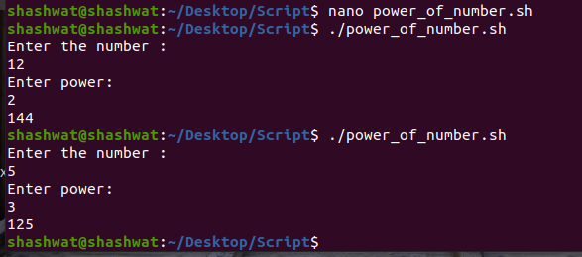

**4. Program to find the quadrant of a point (x,y).**

echo "Enter X-Cordinate"

read x

echo "Enter Y-Cordinate"

read y

if [ $x -gt 0 ] && [ $y -gt 0 ]

then

echo "First Quadrant"

elif [ $x -lt 0 ] && [ $y -gt 0 ]

then

echo "Second Quadrant"

elif [ $x -lt 0 ] && [ $y -lt 0 ]

then

echo "Third Quadrant"

elif [ $x -gt 0 ] && [ $y -lt 0 ]

then

echo "Fourth Quadrant"

fi

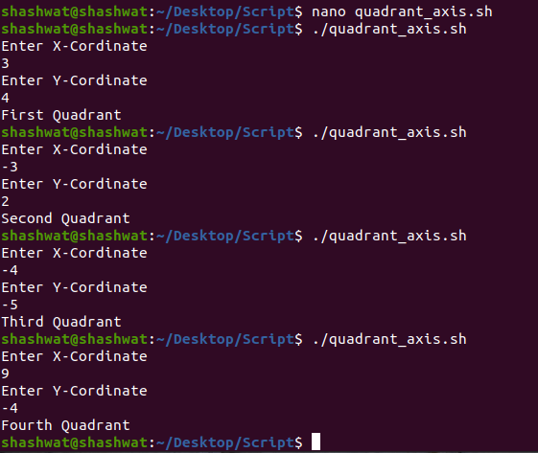

**5. Program to number of words in a given string.**

echo "Enter String"

read a

echo "$a"| wc -w

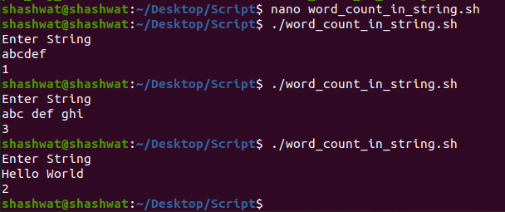

**6. Program to print the factorial of a given number.**

echo "Enter a number : "

read n

res=1

for (( i=2; i<=n; i++ ))

do

res=$((res*i))

done

echo "Factorial of $n is : $res"

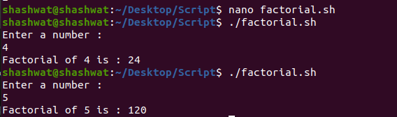

**7. Program to print sum of n terms of fibonacci series.**

echo "Enter number : "

read n

a=-1

b=1

while [ $n -gt 0 ]

do

c=$(($a+$b))

echo "$c "

sum=$(($sum+$c))

a=$b

b=$c

n=$(($n-1))

done

echo "Sum of fibonacci series : " $sum

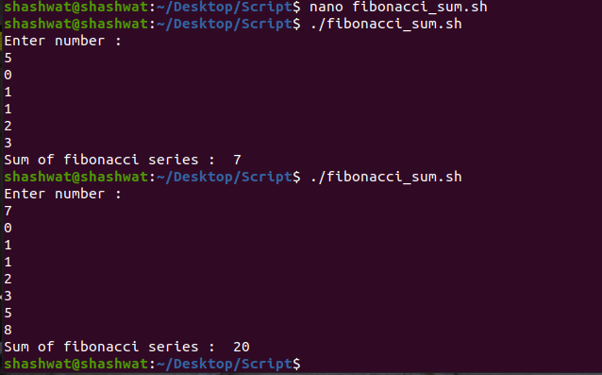

**8. Program to print the sum of alternate odd numbers up to n terms.**

echo "Enter the value of n"

read n

sum=0

for ((i=1;i<=n;i+=4))

do

sum=$(( sum+i ))

done

echo "Sum of alternate odd numbers upto n = $sum"

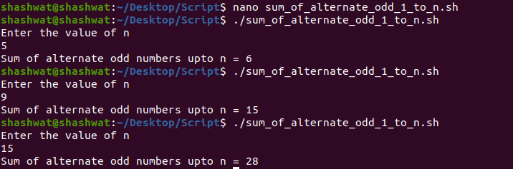

**9. Program to print the next leap year.**

#!/bin/sh

echo "Enter the year"

read year

x=$(( $year % 400))

y=$(( $year % 100))

z=$(( $year % 4))

if [ $x -eq 0 ] || [ $y -ne 0 ] && [ $z -eq 0 ]

then

echo "Entered year - $year is a leap year"

echo "Next Leap Year is" $(($year+4))

else

echo "Entered year - $year is not a leap year "

temp=$(($year%4))

if [ $temp -gt 2 ]

then

temp=$((4-$temp))

fi

echo "Next Leap Year is" $(($year+$temp))

fi

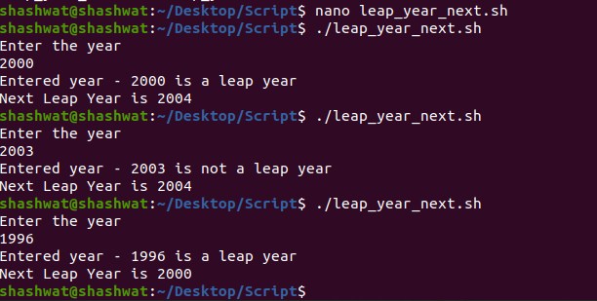

**10. Program to count number possible with the digits of given integer. Also print possible integers with unique digits.**

echo "Enter any number : "

read m

#finding factorial of number of digits

fact_m=1

c_m=${#m}

while [ $c_m -gt 1 ]

do

fact_m=$((fact_m*c_m))

((c_m--))

done

#finding uniques in given digits

n=${m:0:1}

for (( i=1;i<${#m};i++ ))

do

for (( j=0;j<${#n};j++ ))

do

if [ ${n:$j:1} == ${m:$i:1} ]

then

break

elif [ $j == $((${#n}-1)) ]

then

n+=${m:$i:1}

fi

done

done

#finding factorial of repeated numbers

fact_n=1

for (( i=0;i<${#n};i++ ))

do

cnt=0

for (( j=0;j<${#m};j++ ))

do

if [ ${m:$j:1} == ${n:$i:1} ]

then

((cnt++))

fi

done

while [ $cnt -gt 1 ]

do

fact_n=$((fact_n*cnt))

((cnt--))

done

done

echo "Number of possible numbers with digits of given number : $((fact_m/fact_n))"

#finding all permutation of unique digits

s=(${n:0:1})

for (( i=1;i<${#n};i++ ))

do

l=0

for (( j=0;j<${#s[@]};j++ ))

do

for (( k=0;k<=${#s[j]};k++ ))

do

t[$l]=${s[$j]:0:$k}${n:$i:1}${s[$j]:$k}

((l++))

done

done

s=("${t[@]}")

done

echo "All Possible numbers with unique digts of given number : "

for i in ${t[@]}

do

echo $i

done

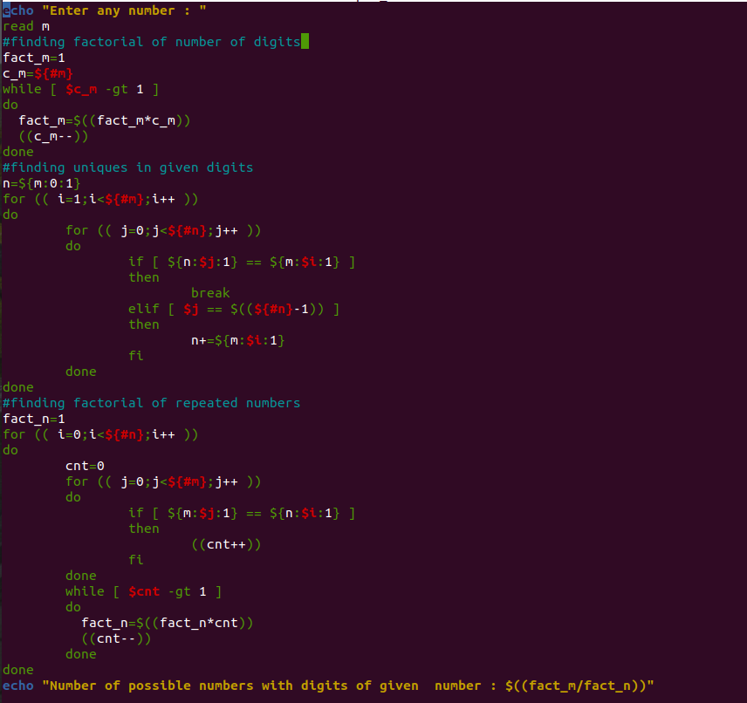

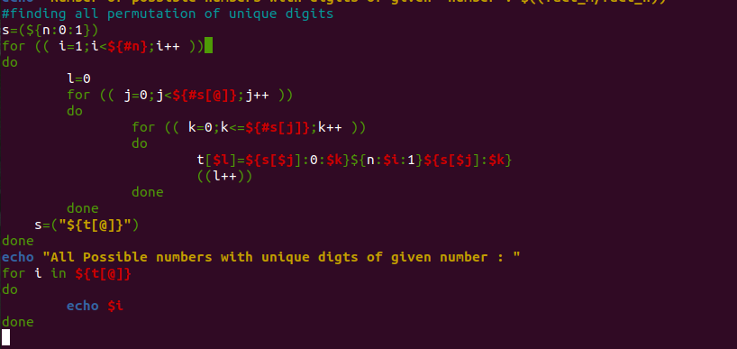

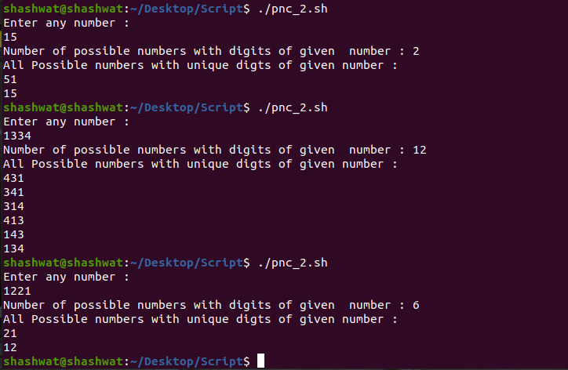

**11. Program to calculate the compound interest (Principle, Rate and Time (years) is entered by the user).**

# !/bin/sh

echo "Enter the principal: "

read p

echo "Enter the rate: "

read r

echo "Enter the year: "

read year

temp1=$(echo "scale=4; 1 + $r / 100" | bc)

temp2=$(echo "scale=5; $temp1 ^ $year" | bc)

amount=$(echo "scale=5; $p * $temp2" | bc)

echo -n "Compound Interest is: "

echo "scale=5; $amount - $p" | bc

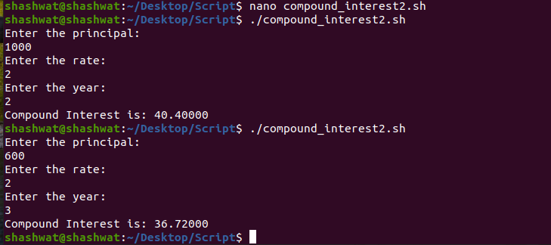

**12. Program to print the prime numbers in a given range.**

echo "Enter the range to print prime numbers"

read start end

count=0

if [ $start -le 2 ]

then

start=3

fi

for ((i=start;i<=end;i++))

do

prime=1

for ((j=2;j<i;j++))

do

if [ $(( i%j )) -eq 0 ]

then

prime=0

break

fi

done

if [ $prime -eq 1 ]

then

echo $i

count=$(( count+1 ))

fi

done

echo "Total prime numbers in the given range=$count"

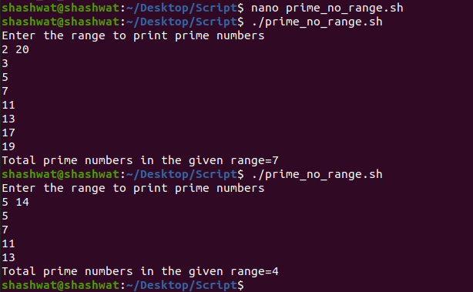

**13. Program to print vowels present at odd positions in an entered string.**

echo "Enter a string"

read str

l=${#str}

for ((i=0;i<l;i+=2))

do

c=${str:i:1}

if [[ $c == [AEIOUaeiou] ]]

then

echo $c

fi

done

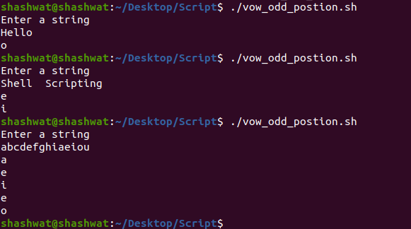

**14. Program to print the 2nd last vowel of an entered string (String can be more than one word like “Shell Scripting”).**

echo "Enter a string"

read str

l=${#str}

count=0

for ((i=l;i>0;i--))

do

c=${str:i:1}

if [[ $c == [AEIOUaeiou] ]]

then

count=$(($count+1))

fi

if [ $count == 2 ]

then

echo "Second Last Vowel is : $c"

exit

fi

done

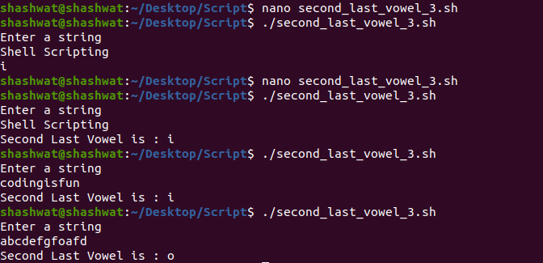

**15. Program to count palindromes in a list of command line arguments. (eg. MADAM).**

#! /bin/bash

count=0

for word in $*

do

rev=""

i=`expr ${#word} - 1`

while [[ $i -ge 0 ]]

do

ch=${word:$i:1}

rev="$rev$ch"

i=`expr $i - 1`

done

if [[ $rev == $word ]]

then

count=`expr $count + 1`

fi

done

echo "Number of Palindrome words in command line arguments are: $count"

